IMPORTANT DATES THIS TERM

The month of May is dedicated to Our Lady

The ascension of the lord
(10 May)
After his Resurrection, Jesus appeared to his disciples over a period of forty days. Ascension Day is when we celebrate Jesus’ return to his Father in Heaven.

Pentecost sunday
(20 May)
This is the day we celebrate the coming of the Holy Spirit and the birthday of the Church.

The most holy trinity
(27 May)
Today we celebrate our belief in the Trinity, the three persons of God: the Father, the Son and the Holy Spirit.

The most holy body and blood of the lord
(3 June)
On this feast we give thanks to God for the gift of Jesus in the form of bread and wine.

The most sacred heart of jesus
(8 June)
On this day we remember how much Jesus loves us all.

Ss Peter and paul, apostles
(29 June)
We celebrate the lives of these important saints who helped establish the Christian Church.

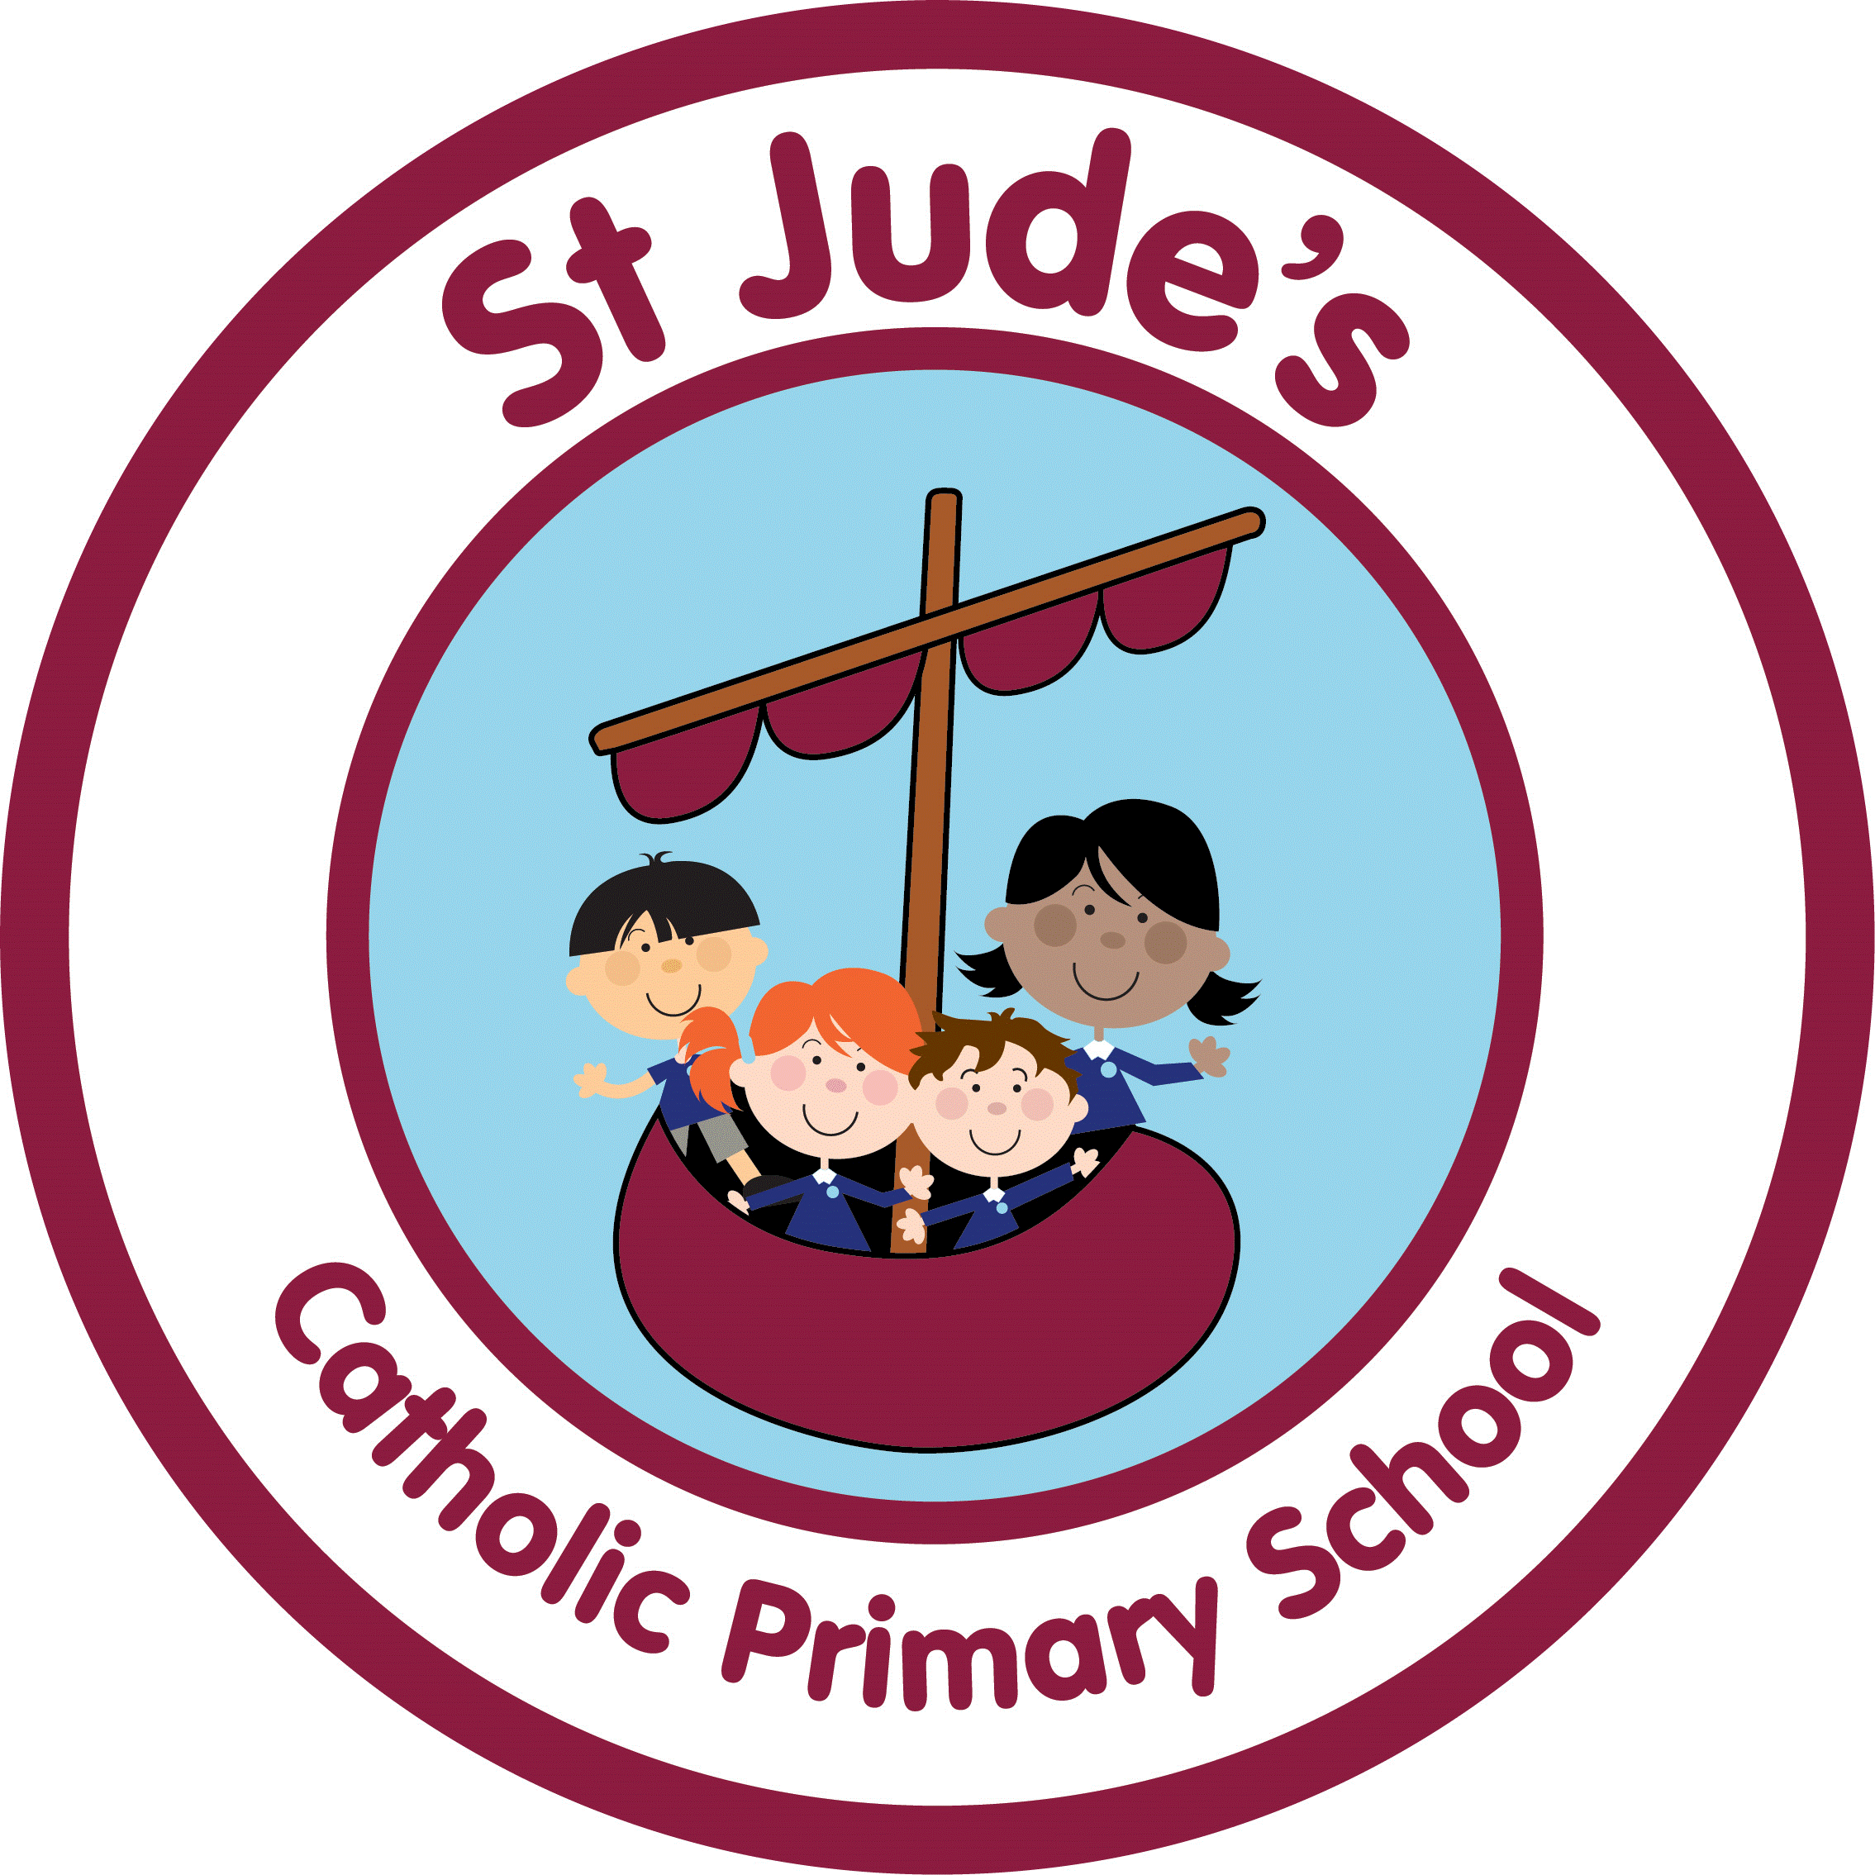
Pentecost—serving
(16.04.18 – 11.05.18)

Early YearsGOOD NEWS - Passing on the Good News of Jesus
Year 1Holidays and Holydays - Pentecost: feast of the Holy Spirit
Year 2spread the word - Pentecost: a time to spread the Good News
Year 3ENERGY - Gifts of the Holy Spirit
Year 4NEW LIFE - To hear and live the Easter message
Year 5TRANSFORMATION - Celebration of the Spirit’s transforming power
Year 6 WITNESSES - The Holy Spirit enables people to become witnesses
Suggestions for home activities

Talk about good news in your family and how you shared it.
Ask your child to tell you the story of Pentecost and the work of the Holy Spirit.

Reconciliation—inter-relating
(04.06.18 – 29.06.18)

Early YearsFRIENDS - Friends of Jesus
Year 1BEING SORRY - God helps us choose well
Year 2RULES - Reasons for rules in the Christian family
Year 3CHOICES - Importance of examination of conscience
Year 4BUILDING BRIDGES - Admitting wrong, being reconciled with God and each other
Year 5FREEDOM & RESPONSIBILITY - Commandments enable Christians to be free & responsible
Year 6 HEALING - Sacrament of the Sick
Suggestions for home activities

Talk together about times when you have forgiven and been forgiven.
Discuss the importance of saying sorry. Look for opportunities for forgiveness and reconciliation in the day to day life of the family.

Universal church—world
(02.07.16 – 20.07.18)

Early YearsOUR WORLD - God’s wonderful world
Year 1NEIGHBOURS - Neighbours share God’s world
Year 2TREASURES - God’s treasure; the world
Year 3SPECIAL PLACES - Holy places for Jesus and the Christian community
Year 4GOD’S PEOPLE - Different saints show people what God is like
Year 5STEWARDSHIP - The Church is called to the stewardship of Creation
Year 6 COMMON GOOD - Work of the worldwide Christian family
Suggestions for home activities

Together, look through a family scrapbook or photograph album of a visit to a place that is special for your family.
Look at a globe or an atlas. Find a special place and pray for the people of that country.
Discuss how we can look after our world and support our neighbours, near and far.

Dear Parent(s)/Carer(s),
As we return to school after Easter the Church is still celebrating this great event. The focus of this term’s work in Religious Education is the role the Holy Spirit plays in our lives. We will be studying the three themes of Pentecost (Serving), Reconciliation (Inter-relating) and Universal Church (World).
Religious Education
Summer Term 2018
Come and See at home

